**ECE 09495/09595**

**Assignment 5 - Jacob Matteo**

**Instructions**

1. Max Credit: 100 Points
2. All questions are from the Textbook – Dive into Deep Learning (<https://d2l.ai/>).
3. Submit a single PDF.
4. Please do not include code. Upload the code to your GitHub, share it publicly and add link in the assignment.

[**https://github.com/jmatteo/Machine-Learning-Fall-20**](https://github.com/jmatteo/Machine-Learning-Fall-20)

**Questions**

**Part – I -** 25 Points

1. Section 13.4.6 – Exercises 1 and 2
   1. Exercise 1 - Change the sizes and ratios values in the multibox_prior function and observe the changes to the generated anchor boxes.
      1. Default: 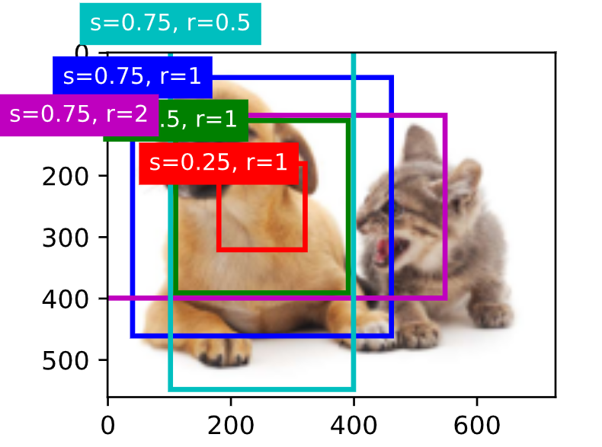

Y = npx.multibox_prior(X, sizes=[0.75, 0.5, 0.25], ratios=[1, 2, 0.5])

* + 1. Test1: 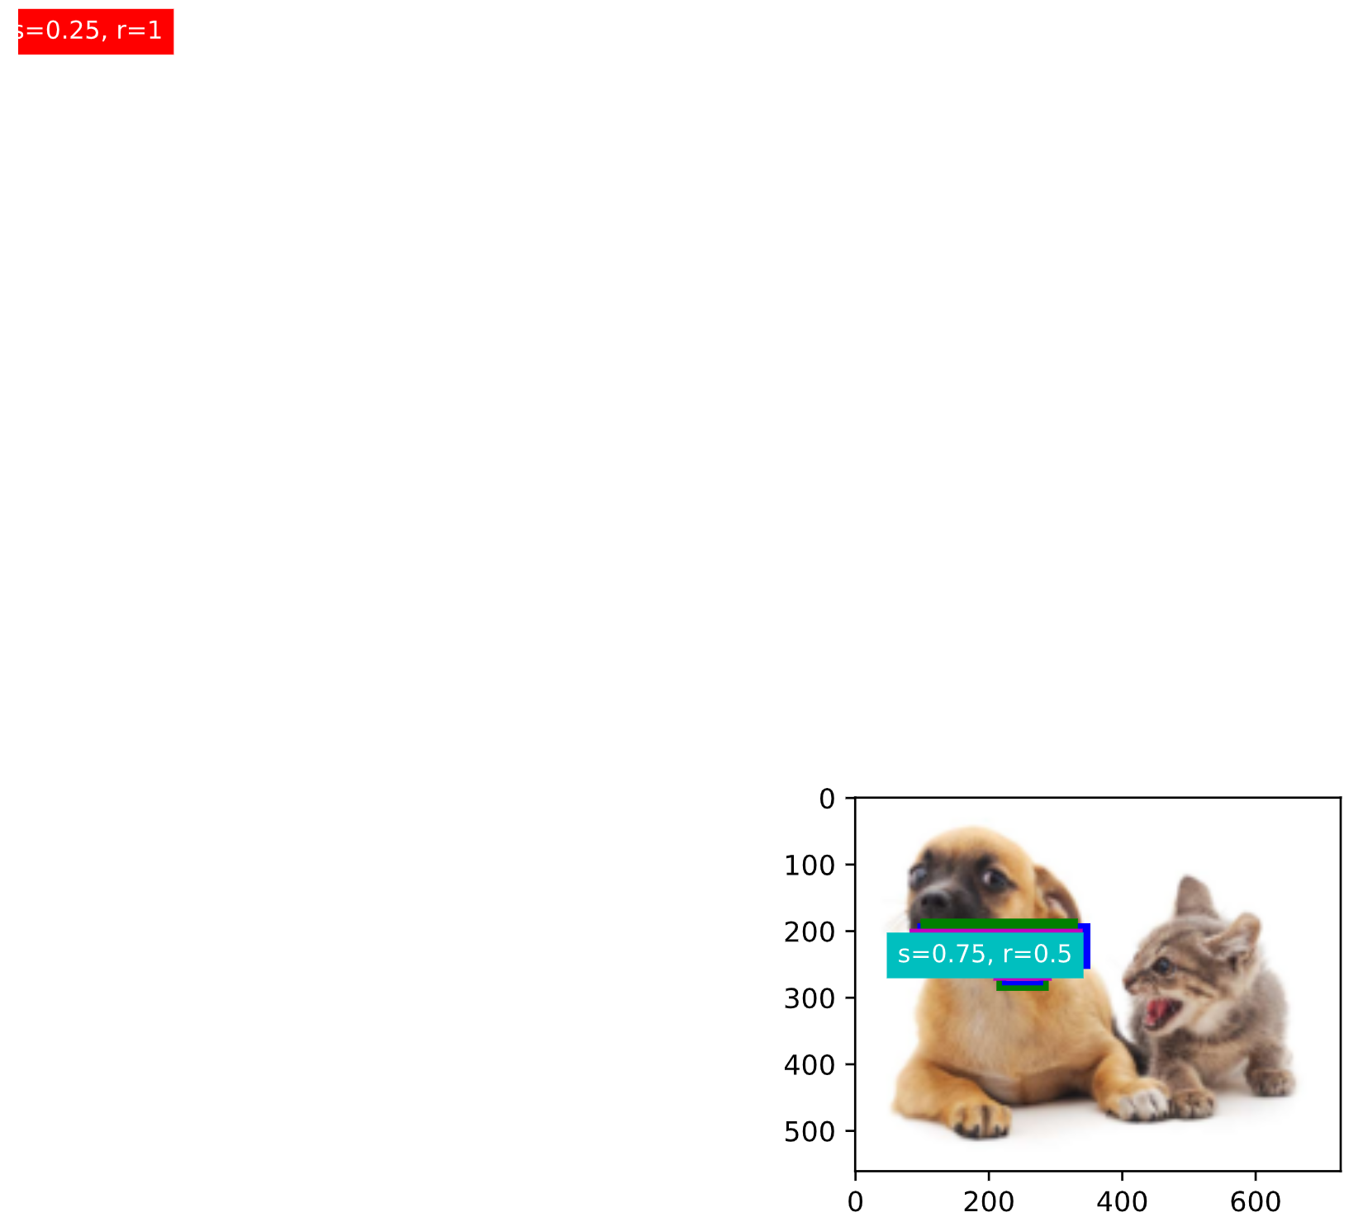

Y = npx.multibox_prior(X, sizes=[0.1, 0.125, 5], ratios=[1, 2, 4])

* + 1. Test2: 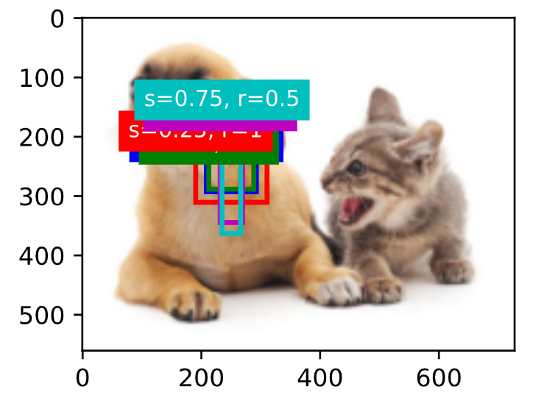

Y = npx.multibox_prior(X, sizes=[0.15, 0.135, .214], ratios=[1, 0.2,0.14])

* 1. Exercise 2 - Construct two bounding boxes with an IoU of 0.5, and observe their coincidence.
     1. 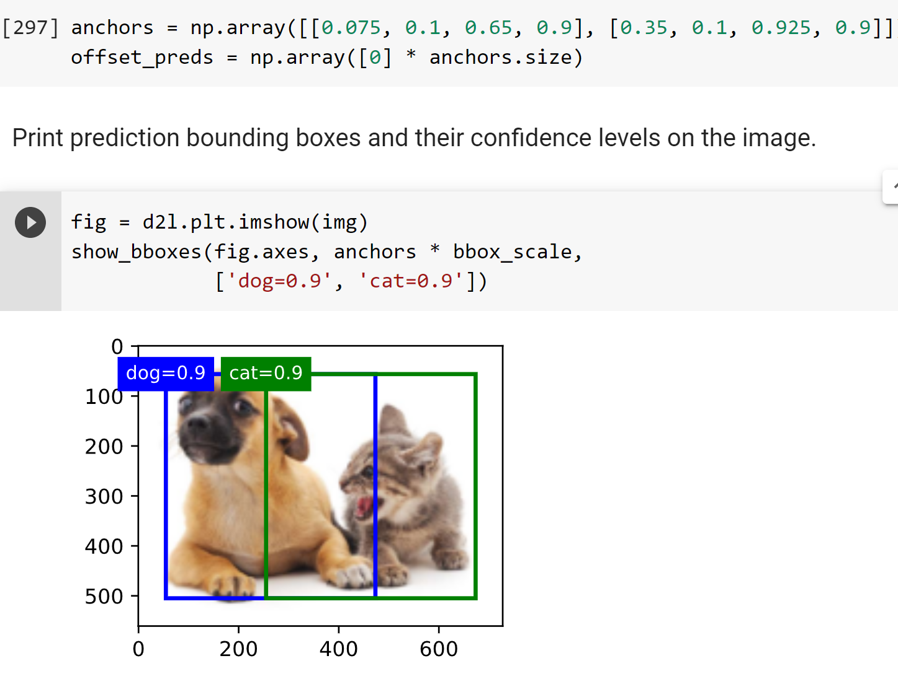
     2. 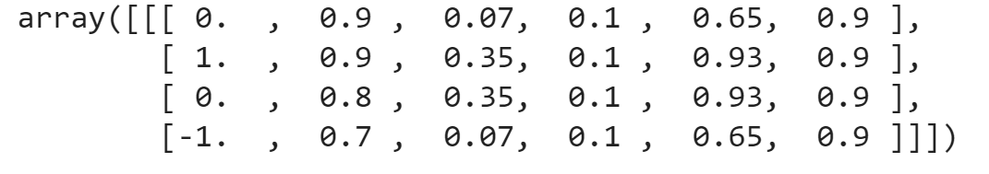
     3. 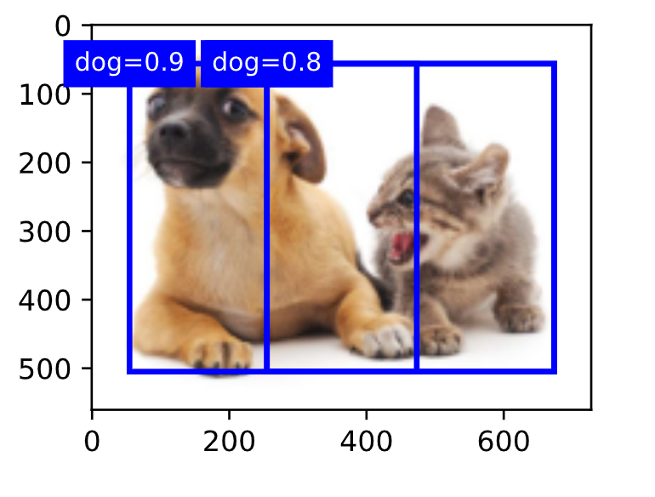
     4. Based on this, coincidence gets pretty low

1. Section 12.5.9 – Exercise 1 - When training on multiple GPUs, change the minibatch size from b to k⋅b, i.e., scale it up by the number of GPUs.
   1. Default: 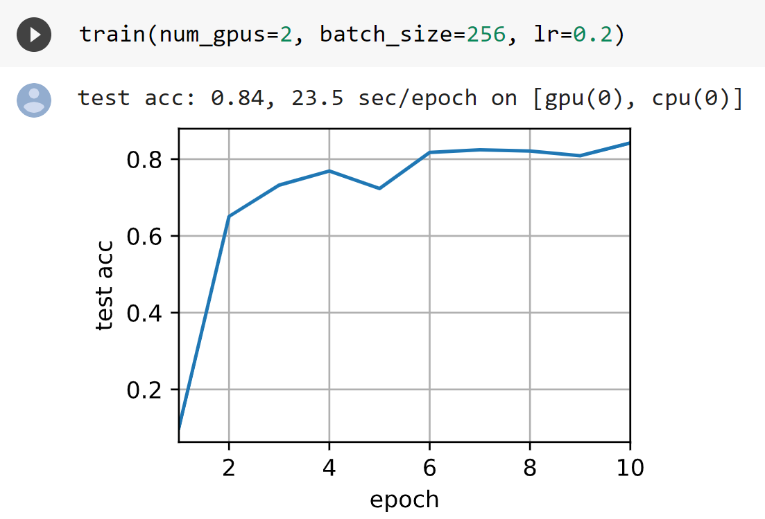
   2. Batch size * num GPU (2): 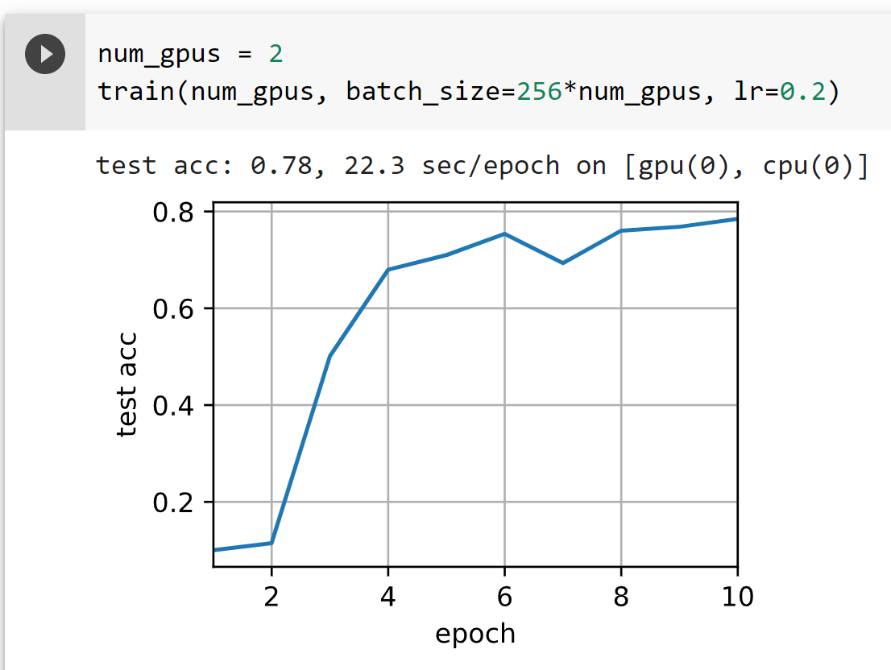
2. Study Object detection in TensorFlow/PyTorch/MXNET
   1. ok

**Part – II** - 25 Points

1. Section 13.10.5 – Exercise 1
   1. Convolutions may be done using a matrix implementation, but a pure implementation is not very efficient. Compared to the built-in matrix convolution functions via PyTorch, a straight matrix multiplication scales at a rate of O(n2), performing much worse at high input matrix sizes.
   2. <https://towardsdatascience.com/how-are-convolutions-actually-performed-under-the-hood-226523ce7fbf>
2. Section 13.11.7 – Exercise 4
   1. Default: 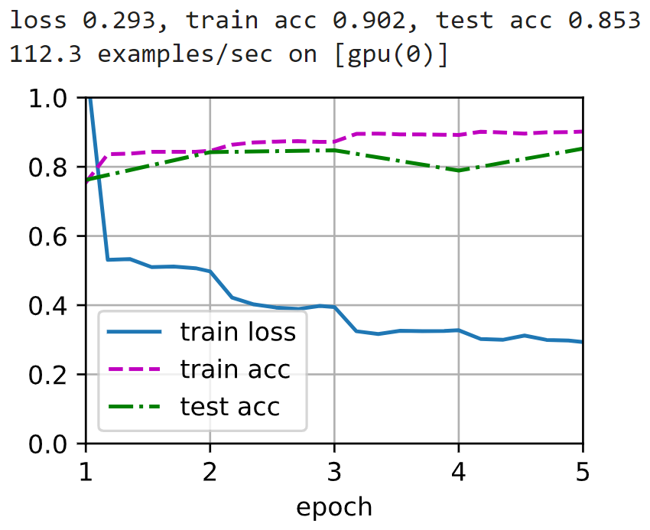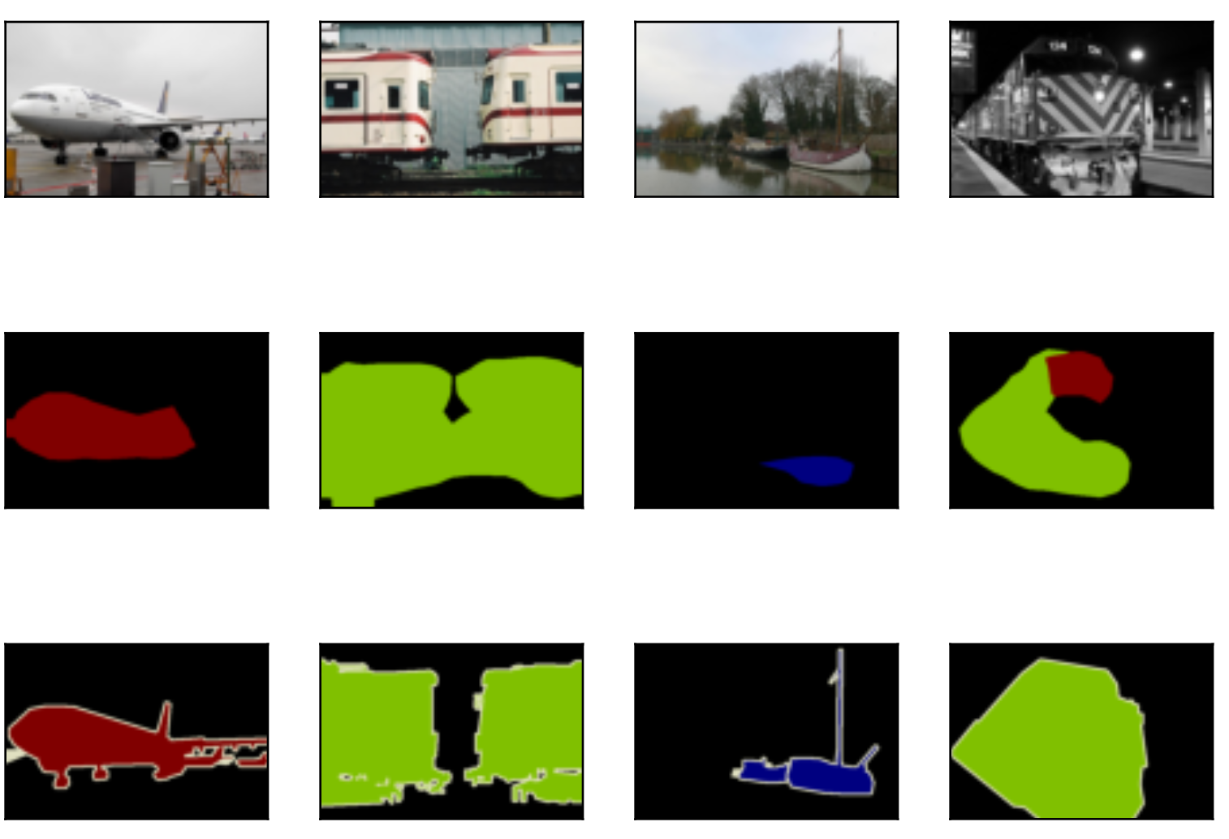
   2. Custom: 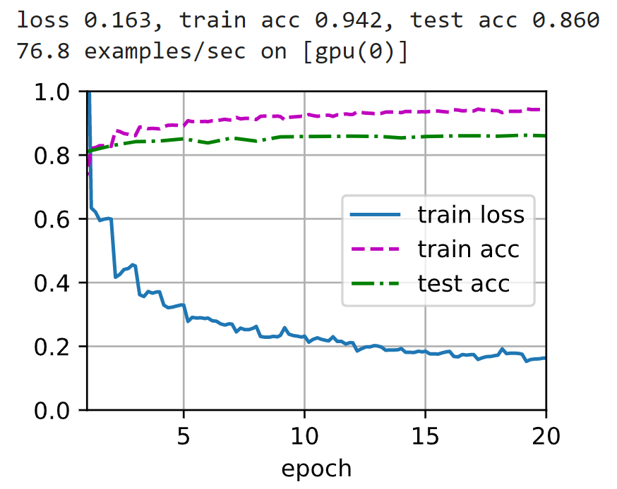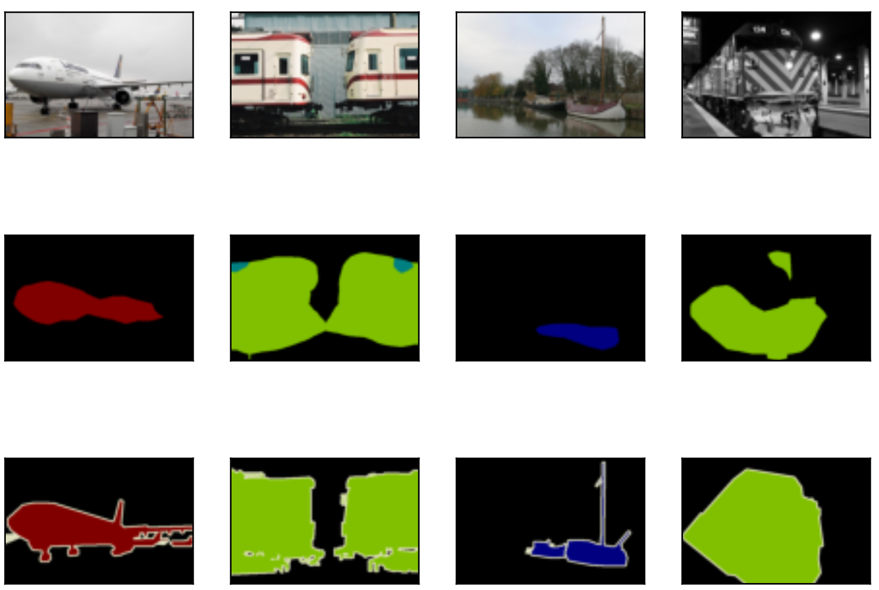

**Part – III**

1. Section 13.13 - Image Classification (CIFAR-10) on Kaggle - 25 Points
   1. Defaults: 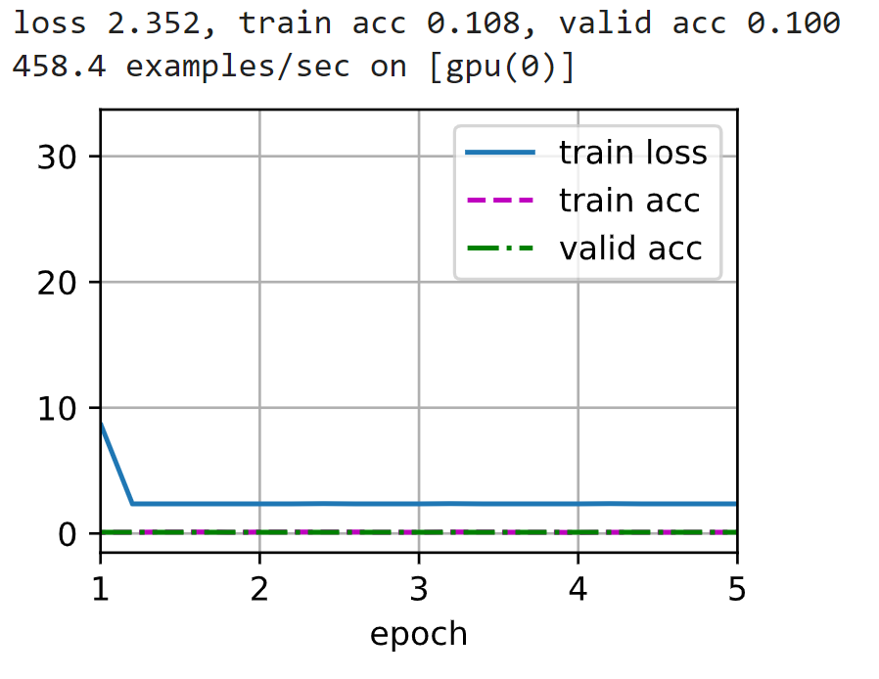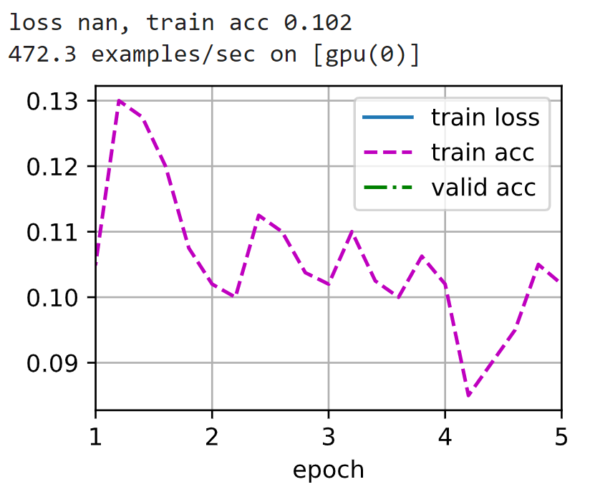
   2. Custom: 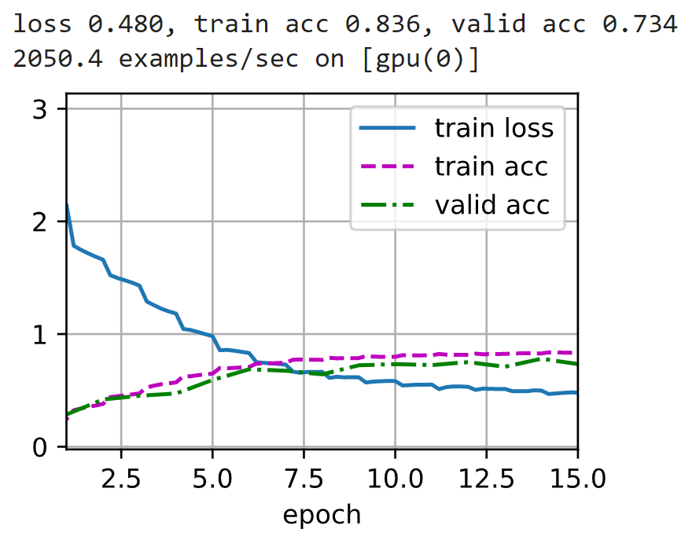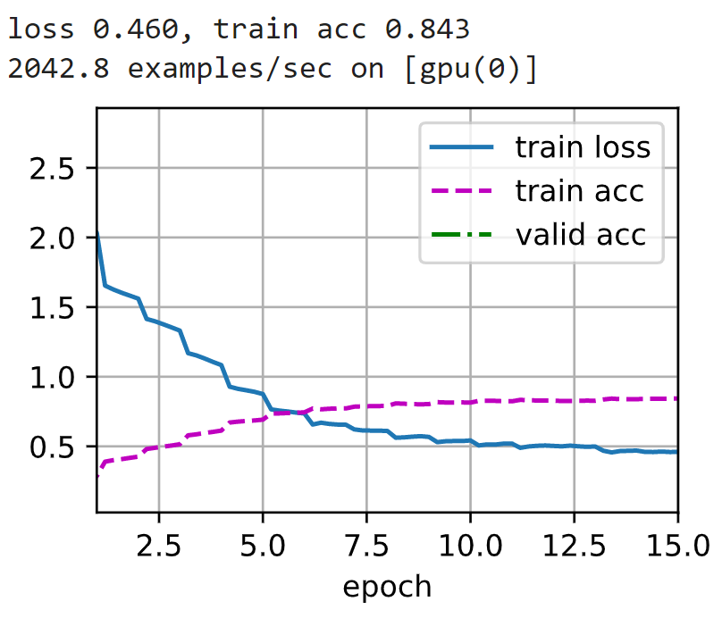

**Part – IV**

1. Section 13.14 - Dog Breed Identification (ImageNet Dogs) on Kaggle - 25 Points
   1. Defaults: 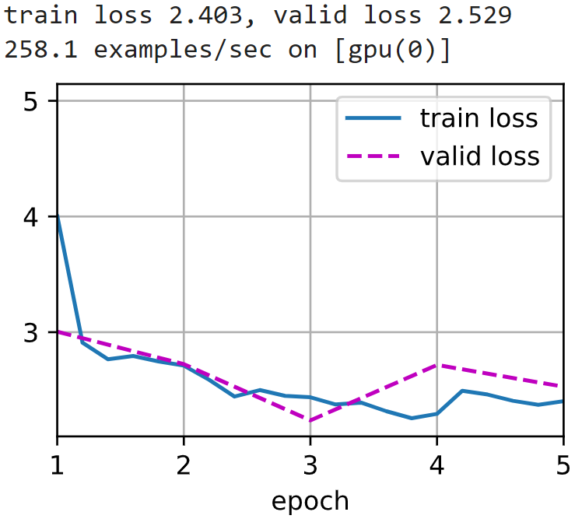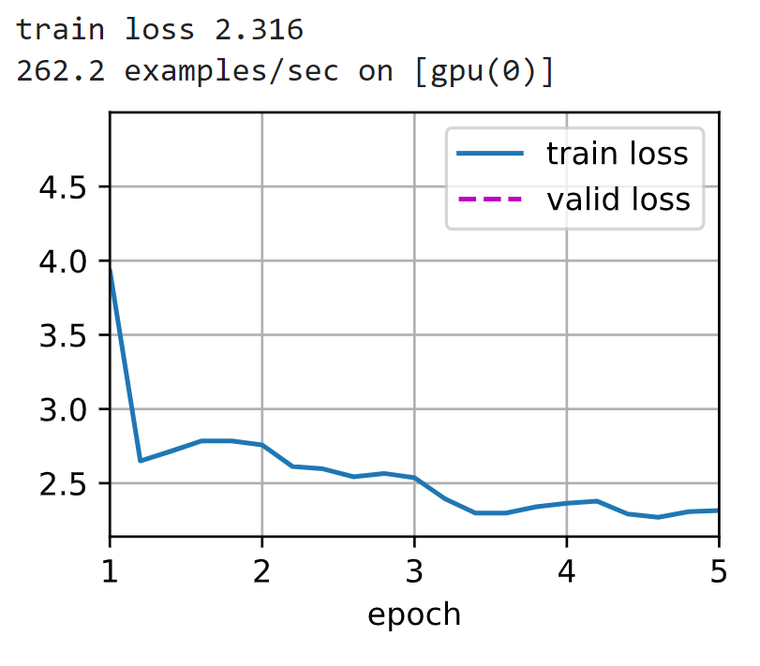
   2. Custom: 